Gosberton Academy

Sports Premium Grant
2025/2026
Planning and Impact document

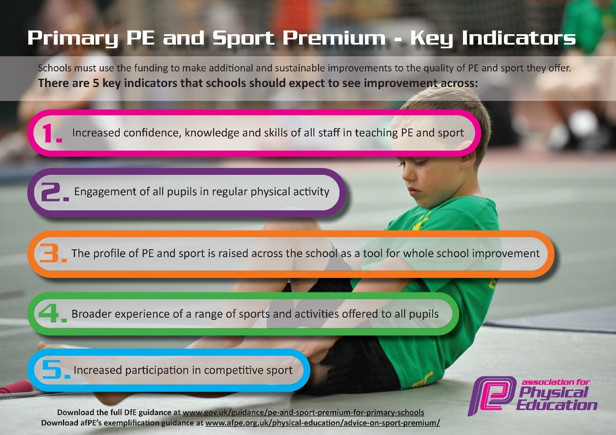
Key Indicators for the Sports Premium Grant spending

Reporting tool categories
Allocation total : £17150
CPD | Predicted Spend | Actual Spend
External Training Course | 0
Upskill to deliver swimming
CPD Internal Learning and Development | 1140
Online Training/ Resources Development | 0
External Coaches – Confidence and confidence
Internal
Extra Curriculum -Anything beyond normal comp | 3840 +700 +700+2305
Internal Sports Comp
Top Up Swim | 1000
Active Travel – WOW/Walk/Stride | 0
Equipment and resource | 1000
Internal Membership Fees | 0
Educational platforms and resources | 0
External
School Games | 2600
Inter-school Sports Competition | 2305
External Coaching Staff | 0
Total Spend | £15590 (so far)

Intent  (Key indicator(K1) reference) | Implementation | Predicted Spend  & Category | Actual spend | Impact  (Positive/None/Negative/Not sure)
- To use external coaches to facilitate after-school activities | - Schedule after-school activities  - Ensure learners have opportunities to sign up and attend activities.  - Ensure plans in place to expose learners to a range of new sports and activities across the year. | £2640
- To attend competitive and developmental sessions organised by Boston Sports Partnership | - Sign up to events from allocated list  - Ensure a range of sports are selected and attended by our learners.  - Create a log to track participation across learners | £2600
- To attend competitive sporting events and developmental sessions organised by Elite Sports | - Sign up to events  - Create a log to track participation across learners | £4610
- Organise two ‘Wow’ Day visits from inspirational sporting athletes | - Organise the event  - Ensure all learners are involved in the days  - Work alongside the athlete to ensure other curriculum areas can be supported throughout the day. | £1400
- Support PE lead with termly time to allow monitoring, planning and analysis to take place | - Plan created to ensure termly monitoring can take place  - PE lead to work alongside staff and external PPA cover to ensure PE and Sport planning is on track for academic year. | £1140
- Purchase equipment to ensure PE and Sport can be accessed by all with the most suitable and appropriate equipment | - Audit school equipment  - PE lead to organise equipment that could be purchased.  - Purchases to be made throughout the year. | £1000
- To contribute to all Year 5 and 6 learners PGL residential visit ensuring all learners have the opportunity to attend. | - Ensure all learners/parents are aware of PGL and the support in place  - Regular communication with families to try and ensure as many as possible attend the residential | £1850
- Ensure Year 6 learners leave Primary School able to swim 25m with a range of strokes.  For those that achieve the national curriculum expectations, additional learning will be implemented to further strengthen their swimming and water awareness. | - Regular monitoring of swimming abilities throughout curriculum lessons.  - Additional support in place for non-swimmers through top-up swim availability.  - Additional water activities arranged for those meeting curriculum expectations early. | £1000

Swimming | Water safety | 25m | Strokes
%

